Here’s today and tomorrow’s lesson. You know most of these things. Copy the lesson in your notebook and if there are some words you don’t know, check them in the dictionary. Mind the pronunciation as well!

IX. ADVENTURES
- TYPES OF HOLIDAYS
- a package holiday - a camping holiday (to pitch a tent)
- an adventure holiday - a sightseeing holiday
- a honeymoon (after a wedding day) - a sailing holiday (a yacht)
- a walking/ hiking tour - a spa holiday
- a working holiday (working as a volunteer) - hitchhiking

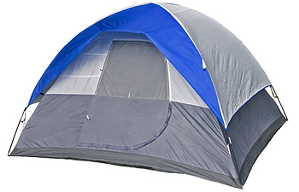
- EQUIPMENT
- a backpack, a suitcase, a sports bag
- documents (id, medical insurance card),
- (pocket) money, valuables (money, jewellery, documents)
- clothes
- a tent, a sleeping bag
- first-aid kit
- a hygiene bag ( a tooth paste, a toothbrush, sun cream…)

- WAYS OF TRAVELLING
We can travel by bus
van - a person travelling is called a passenger
caravan
train - when travelling by public transport, you can buy
ship/boat a single/ a return ticket
subway
lorry - the aim of your travelling is called a destination
ferry
helicopter/plane
scooter/bike

- PROBLEMS we can face when travelling:
- You can run out of money
get robbed
have bad weather
problems with your luggage
problems with the language
be afraid of heights
be afraid of flying
get seasick
get food poisoning
get dehydrated
miss a ferry/ a flight
-
- HEALTH PROBLEMS & INJURIES
ILLNESSES DISEASES (they’re more serious than illnesses)
to cough /kof// sneeze to have/ suffer a (lung/breast) cancer
to have a runny nose a heart attack
to have flu/ a cold/a sore throat a stroke
a diarrhea a (brain) tumor
a blister
a bruise or a bump
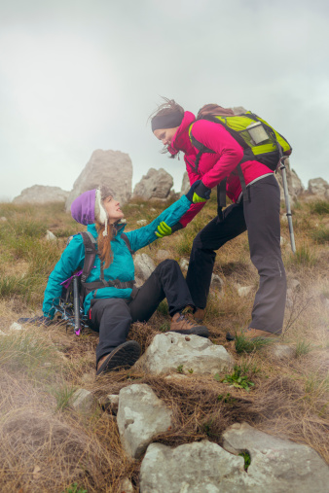
INJURIES:
You can have a broken arm/ leg you need a plaster
a twisted/ sprained ankle
a backache
feel a pain in your leg ------------------- your leg hurts
get a cut (cut your finger) you need a sticky plaster

RULE No. 1: IN CASE OF AN ACCIDENT YOU MUSTN’T PANICK!!!

Now learn the vocabulary. Enjoy

