10. CLOTHES
1. Label the clothes.
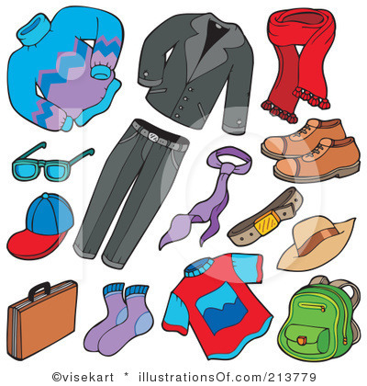
a pullover a scarf
sunglasses a tie
a cap shoes
a suitcase a belt
a jacket a hat
trousers a T-shirt
socks a backpack
2. When I go running, I put trainers on my feet. But when I’m at school, I must wear slippers
3. A vest, underpants and knickers are called underwear
4. It’s so cold outside. You must put on tights under your jeans.
5. Boots are made of rubber, shoes are made of leather and a T-shirt is made of cotton.
6. Make sure you put on good hiking boots if you want to go to the mountains with me tomorrow.
7. I don’t like woolen (volnen) pullovers. They’re so itchy.
8. Women wear earrings in their ears but married women wear a ring on they left finger.
9. How much money have you got in your wallet? I don’t know. I have to look in my pocket.
10. Little girls often wear leggings because they don’t like baggy tracksuits or jeans.
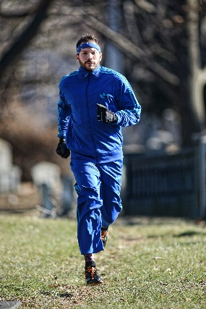
11. What’s another word for a sweater? A jumper or a pullover.
12. How do you call clothes like sweatshirts, jeans and T-shirts? Casual.
13. What do you wear to do sports in the cold weather? A tracksuit.
Volnen pullover- a woolen pullover ozke hlače- tight trousers
Dragi uhani- expensive earrings zlata ogrlica- a golden necklace
Bombažna majica- a cotton sweatshirt usnjen pas- a leather belt

11. FILL IN THE CORRECT FORM OF A PRONOUN.
1. I will never go on holiday with him (he) again! 5. Do you think she (she) likes me (I)?
2. We were worried about you. You should call us 6. Did he (he) come by car?
3. Ask them if they will join us (we). 7. I think I gave them (they) to her (she).
4. Why do they (they) make us (we) so crazy? 8. Her (she) house is next to our (we) house.

12. WRITE THE OPPOSITES. Be polite!!!!
A pretty young woman- a plain woman a short overweight man- a tall slim/ thin man
Baggy clothes- tight clothes a well- dressed man- a badly- dressed man
Thick hair- thin hair thin lips- full lips
To put on a jacket- to put off a jacket at the beginning of the street- at the end of the street
An excited boy- a bored boy a moody uncle- a cheerful aunt

13. FORM QUESTIONS FOR THE UNDERLINED WORDS.
Monika hurries to school. Where does Monika hurry?
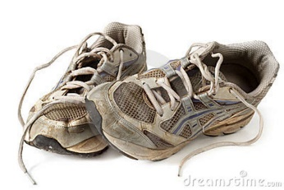
I can’t run because my knee hurts. Why can’t you run?
Tom’s wearing a tracksuit today. What is Tom wearing today?
She’s got three pairs of trainers. How many pairs of trainers has she got?
Bob and Mike go to school by van. Who goes to school by van?
Josh lives with his parents. Who does Josh live with?
She has a crush on him. Who does she have a crush on?
They’re waiting outside the church. Where are they waiting?

We’re almost at the end Do the final two exercises (both 14s) and send the last three pages to my email address (sandra.kozorog@os-kobarid.si) until Thursday, 2nd April, 7pm. It seems this is going to be one of your marks Most of you have done the first part great. Thank you so much!!!
(Saj vem, da ste vsi razumeli, pa vendar…. Smo skoraj na koncu ponavljanja. Naredite še zadnji dve vaji in mi zadnje tri strain (naloge 10, 11, 12, 13 in ob 14ki) pošlji na mail do četrtka, 2.aprila do 19.00. Vse kaže, da bo to ena izmed vaših ocen. Večina vas je 1.del odlično opravila. Najlepša hvala!!!

