Končno, na koncu To je bil kar intenziven pregled snovi in upam, da vam je/ vam bo kaj koristilo. In JA, ogromno smo se naučili CONGRATULATIONS!!! I’M PROUD OF YOU! Preostaneta nam samo še dve vaji, da ju pregledate, potem pa le poglejte od časa do časa kakšen prevod, kako tvorimo vprašanje….
14. FREE TIME, HOLIDAYS AND SUGGESTIONS
1. V prostem času rada gre na sprehod. She likes going for a walk in her free time.
2. Ne mara vrtnarjenja, rada pa potuje. She doesn’t like gardening, but she likes travelling.
3. Njeni otroci sovražijo pohodništvo, vendar pa obožujejo plezanje. Her children hate hiking, but they love climbing.
4. Odvisen je od računalniških igric. He’s addicted to computer games.
5. Ali je odvisen od iger na srečo? Is he addicted to gambling?
6. SUGGESTIONS. Suggest your friends to go hiking. Let’s go hiking.
Shall we go hiking?
Why don’t we go hiking?
7. Name 5 reasons why people go on holidays? They go on holidays to relax, to have fun, to forget about problems/ school, work, to recover from a disease, to learn about new cultures, to learn a new language, to make friends, to meet new people……
8. You can put your luggage in your suitcase, your sports bag or in a backpack
9. Ne pozabi zdravstvene kartice in osebne izkaznice! Don’t forget your health insurance card and your ID (identity card)
10. Ali je tvoja žepnina dovolj visoka, da greš kampirat? Is your pocket money high enough to go camping?
11. Name 5 things that can go wrong when you are on holidays. You can run out of money, you can get sick, you can get robbed, you can run out of petrol, you can get lost, you can have bad weather....
12.Michael ti ne more pomagati, ker mora pospraviti postelje. Michael can’t help you because he must make his bed.
14. THE WEATHER & THE SEASONS
1. Obleči si moraš vetrovko, ker je zunaj zelo hladno in vetrovno. You must put on your anorak because it’s very cold outside.
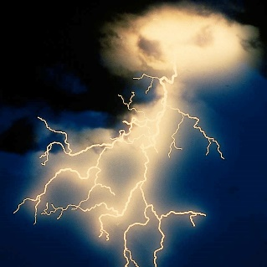
2. Sneži, zato se lahko gremo sankat. It’s snowing so we can go sledging.
3. Boji se neviht. Ko grmi in so strele, ne more spati. He’s afraid of storms. He can’t sleep when there’s thunder and lightning.
4. Rahlo je megleno, vendar pa mislim, da bo vreme v redu. It’s misty (a bit foggy) but I think the weather will be OK.
5. Ali nabirate gobe jeseni? Do you pick mushrooms in autumn?

